 ***Good News***

**Vol. 33 Num. 10 October, 2018**

Dear Members and Friends of Trinity,

As you know, we have been looking at ways to get into the community more and through those efforts hopefully make friends and have opportunity to invite people to church. So far, our efforts have been aimed at serving children with athletic and educational camps. As we went through the New Beginnings report, it was also suggested that we look for ways to engage the parents of school age children more directly. The idea has been discussed a couple of times and has been well received, but as of yet nothing has come together. We need to change that.

I am scheduling a think tank for October 14 after service to get this moving and hopefully have some plans in place for Christmas time and the New Year. There will be lunch provided in the Community Building and kids are welcome to come hang out in the gym, game room and youth room and café while parents and other interested adults participate in the think tank in the community room. A sign-up sheet will be on the sign-up bar to plan for the food ASAP.

The purpose of this think tank is to generate ideas that might lead to more engagement and connections with 30 and 40 year olds, where we can serve them in needed areas, provide opportunities to make friends, and invite people to church as we are able. This is open to anyone with thoughts on the subject and ideas to try. Talk with your adult children, friends, and neighbors about it. Ask them what a church could do for them and what they would enjoy doing with other folks. Then, bring those thoughts and ideas and participate in the think tank on October 14 after service.

IN THIS ISSUE

Pastor’s Message………………………………………………………...1

Services, Studies & Prayer List…………………………………….2

Trinity Events, Groups & Meetings, and Notes…….….3-7

Photos…………………………………………………………………...8-10

Birthdays, Anniversaries & Memorials...............................11

Financial Report & Parochial Report….………….…….…....12

PPC minutes…….………………………………………………………..13

On a related note, I am going to be starting an Adult Information Course on Saturday nights after service beginning October 13 and running until November 17. The purpose of the course will be to go over some of the basic teachings of the Bible, some distinctive Lutheran ideas, and share some of the opportunities for worship and service at Trinity.

I am envisioning spending an hour or so diving into God's word and Lutheran beliefs, with time for food and fellowship as well. We will use some videos to jumpstart our conversation, and I really am not thinking of this as a school-type class but more as a friendly get-together to discuss life and faith.

Child care will be available, just let me know if you need it. Refreshments will be provided as well. Please sign up in the narthex so I can plan ahead on both counts. If you are newer to our fellowship, you should have received a letter with more details already. I hope you will make plans to attend so I can get to know you better and talk with you about Trinity and our mission in Wyandotte.

If you have questions or would like more information, please don’t hesitate to ask. Call or email me and I will get back to you ASAP.

In Christ,

Pastor Grenz

**OUR MINISTRY STAFF**

*Pastor:* Rev. Greyson Grenz ([ggrenz@wyan.org](mailto:ggrenz@wyan.org))

*Administrative Secretary:* Carissa Schafer ([tlm@wyan.org](mailto:tlm@wyan.org))

*Mission/Ministry Director & Guitarist:*

Mendy Grenz ([mgrenz@wyan.org](mailto:mgrenz@wyan.org))

*Custodians:* Carl Joyce & Bob Freeman

*Organist:* Mary Tollefson, *Music:* Danny O’Neill

***STUDIES & SERVICE***



* *Little Known Books of the Bible,* led by Pastor Grenz, **Saturdays**, 4:00 p.m., Sanctuary & **Sundays**, 8:45 a.m., Sanctuary
* *What Does the Bible Say*, led by Doug Wieneke, **2nd & 4th** **Sundays**, 6:00 p.m., Sanctuary
* *ECHO,* led by Pastor Grenz, **Mondays**, 6:30 p.m., Sanctuary
* *Women of the Bible,* a Women’s Bible Study*,* led by Mendy Grenz, **Tuesdays**, 11:00 a.m., Sanctuary
* *Everyone His Witness*, led by Pastor Grenz, **Wednesdays**, 7:00 p.m., Sanctuary
* *Acts,* led by Pastor Grenz, **Thursdays**, 10:00 a.m., Sanctuary
* A Men’s Bible Study, led by Al Ave-Lallemant, **Thursdays**, 8:00 a.m., Community Building

**SUNDAY SCHOOL**

Sunday School will now be called Cross Training, a bible study for children & youth. It will meet on Saturdays at 4 pm.

If children come during Bible Study on Sundays, there will be packets that they can work through that go through the Bible.

*A BIG THANK YOU to everyone who supported this year’s school supply drive. With your help, we serviced 9 schools and 66 teachers with much needed supplies. We delivered 104 boxes of supplies plus clothes, newspapers, and egg cartons. Everything has been delivered to the schools now.*

*Another thank you to Danny O’Neill for helping us to deliver them.*

*Al & MaryAnn Johnson*



**If you would like to add someone to the list, please fill out a purple prayer request slip, call Carissa in the office (734) 282-5877, OR e-mail** [**tlm@wyan.org**](mailto:tlm@wyan.org)**.**

Parochial Report

August 2018

Baptisms – 0 Average Attendance

Weddings – 0 Aug 2017 Aug 2018 YTD

Funerals – 0

Confirmands – 0 Worship: 80 80 90

Transferred in – 0 Bible Class: 18 21 20

Transferred out –0 Sunday School: 5 n/a 6

Reinstated – 0



**TRINITY EVENTS & PROGRAMS**

**YOUTH MINISTRY NEWS**

Youth group is going well! We average about 10 kids every week. These youth are spending time in the Word, playing games, and fellowshipping with one another.

***Youth Schedule:***

October 7 – ***No Youth Group***

October 14, 21 – **3pm in the youth room**

October 28 – **Trunk or Treat – youth helping**

**NATIONAL YOUTH GATHERING**

We have 4 youth planning to attend the National Youth Gathering in Minneapolis. There will be fundraisers throughout the year to help the youth get there! Watch for ways you can help!

**SAVE YOUR CANS AND BOTTLES!**

The youth will be collecting cans and bottles throughout the year. Bring your cans and bottles to church the first weekend of each month, and the youth will turn them in to help them get to Minneapolis! Thanks for your help!

**TRUNK OR TREAT~SAVE THE DATE!**

Trunk or Treat is October 28, 3:00 – 4:30 p.m. Interested in helping? Do you have a trunk? Great! We are also in need of someone willing to lead this program. Contact Pastor or Carissa in the office for more details. Watch for sign-ups and more information in future bulletins.

**MESSAGE FROM MENDY**

Real. Present. God. This is the theme of the upcoming youth gathering. It is based on Psalm 46.

Take a moment today to read Psalm 46. Verse 1 tells us that “God is our refuge and strength, a very present help in trouble.” We are so blessed to have a very real, present, God. I am looking forward to accompanying the youth to the gathering to watch them grow in their faith and understanding of our God! Please keep Gideon, Luke, Amanda, and Oscar in your prayers as they work and prepare for this awesome experience!

~Mendy Grenz



**TRINITY GROUPS & MEETINGS**

**October 2018**

**TWIM Notes & News**

Seven ladies attended the September 4, 2018 meeting.

**The next regular TWIM meeting is scheduled for Tuesday, October 2th at 10:00 a.m**.

**Fall Rummage Sale**

TWIM’s annual Fall Rummage Sale is **Friday, October 12th,** 12:00 – 4:00 P.M., and **Saturday, October 13th,** 9:00 – 1:00 p.m. Saturday is $2.00 bag sale day. **Set-up is Thursday October 11th beginning at 10:00 a.m.** Help is needed, so stop by during set-up day or on the sale days to lend a hand. Watch the weekend church bulletin for dates and times when your clean usable rummage may be brought in and placed in the designated area. Please DO NOT bring in your rummage before the date advertised!

**We** **cannot accept the following items:** analog TVs, old CRT computer monitors, old desktop computers, used children’s car seats and used cribs**.** These items are NOT accepted by the Purple Heart who kindly takes the leftover rummage after our sale. **We also do not take large bulky furniture**

**LWML Sunday will be coming up the weekend of October** **12th and 13th** Look for the LWML article highlighting this month’s Mission Grant and see where your generous donations are being put to use for the Lord’s work!

**LWML Dearborn/Downriver Zone Fall Rally** will be held **on Saturday, October 20th @ 9:30 a.m. at Christ The King** (16700 Pennsylvania Rd, Southgate).

A new **8-lesson LWML Zone Bible Study begins on Saturday, October 13th, 9:30-11:30 a.m., and will meet on the second Saturday of the month.** Location: Christ the King Lutheran, 16700 Pennsylvania Rd., Southgate. Books are $10.00. Contact Gina Davidson at [davidson2@wowway.com](mailto:davidson2@wowway.com) to register for the class.

**“Treasured”,** a LWML Women’s Retreat (Dearborn/Downriver Zone) will take place **on Saturday, November 3 from 8:00 a.m. – 4:00 p.m. Location: Christ the King (16700 Pennsylvania Rd., Southgate).** The Women of the Pearl will be speaking, and we will make a treasure to take home. The cost is $20.00 which includes lunch and all materials. Your **registration form and payment must be received by October 20th to Gina Davidson**. Registration forms are located on the church sign-up counter.

**Congratulations to Trinity’s Mendy Grenz** who is now the LWML Michigan District’s new website coordinator! She also holds the position of Christian Growth Co-chair for the LWML Dearborn/Downriver Zone!

Trinity Ladies, join us for our next meeting. Visit with friends you already know and meet a few new people too. All ladies are invited to join us and guests are always welcome!

Christie Wilczynski, Secretary

**MEN’S CLUB**

Join us for good food and fellowship on October 12, 7:30 p.m. at Paul Ivity’s home. This is a great time to get to know some of the other men in the congregation. We always have a good time! Please, call Paul or the church office with any questions. All men are welcome!

**WOMEN’S BOOK CLUB**

If you are interested in joining, the next book is The Last Runaway by: Tracy Chevalier. Meeting and discussion will be October 4, 7:00 p.m. in Mendy’s home.

**PPC MEETING**

Sunday, October 7 after service.

**WOMEN’S SPOUSAL SUPPORT GROUP**

A support group just for women, meets on, Wednesday, October 24 in the community building at 10:00 a.m. If you have any questions, please call Nancy Coman, 734-634-0394.

**CAREGIVER SUPPORT GROUP**



**LWML Michigan District Mission Grant Goal for 2018-2020 Biennium—$242,050**

Twelve Mission Grants were selected for funding during the 2018-2020 biennium by the delegates at the July 20-22, 2018 LWML Michigan District Convention. They are listed below:

* 1. Filling pulpits by Providing Scholarships for Michigan Men in Seminary - $25,000
* 2. The Luke Project 52 Mother & Baby Clinic - $25,000
* 3. Financial Assistance for Concordia Theological Seminary Food Co-op to Purchase Food Items - $10,000
* 4. Trinity HOPE Haitian Feeding Program - $15,000
* 5. Acts 2 Enterprise - Impacting Lives in Michigan’s Urban Communities - $25,000
* 6. New Beginnings for Children with Learning Needs - $25,000
* 7. Women Reaching Arab Women with the Gospel in Dearborn MI - $25,000
* 8. Scholarships for Female Students Studying to be a Deaconess or Professional Church Worker - $20,000
* 9. Lutheran Books for Missionaries Around the World (Lutheran Heritage Foundation) - $15,000
* 10 Expanding the Connecting Kids to Christ Tutoring Program - $25,000
* 11. Support for Concordia Seminary’s International Graduate School Students - $10,000
* 12. MOST Ministries Eyeglass Edger - $22,050

The group meets Wednesdays, October 3 & 17 at 10:00 a.m. in the Community Building. If you have any questions, please call Nancy Coman, 734-634-0394. **One way that we can support the members of our caregiver support group is to clip coupons for incontinence products, so if you are a coupon clipper, please save those coupons and bring them into the office.**

**National Mission Grants for 2017-2019**

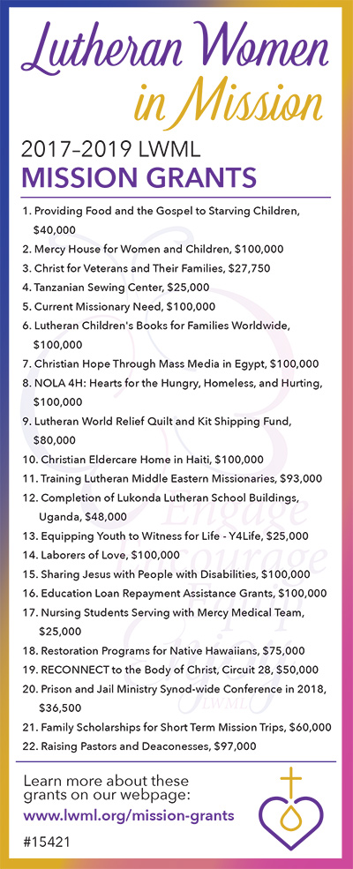

***MORE NOTES & SERVICE OPPORTUNITIES***

**NAME STAMP SPONSORS-THANK YOU**

Thank you to everyone who helped to sponsor a stamp for the Lincoln Center students. We were able to buy 15 stamps!

The Endowment Fund has 6 cemetery lots for sale.

**Glen Eden Lutheran Memorial Park:**

Section 228, Graves 3&4, Block 16 – Garden of Hope, $900.00 each. (Current value $1,500.00 each)

Section 1662, Graves 1, 2, 3 & 4, Block 20 – Garden of Holy Trinity, $780.00 each or 4 lots for $2,800 (Current value $1,300 each)

**If an individual would prefer a different lot or location at Glen Eden Lutheran Memorial Park than those listed above, they could purchase the above lot/lots for the price indicated and Glen Eden Lutheran Memorial Park will apply the current lot value of either $1,300 or $1,500  towards the purchase of any other available lot within the Park. For additional information on this purchase and transfer procedure you may contact Floyd Schafer at 734-285-3293 or call a Service Representative at Glen Eden Lutheran Memorial Park at 1-248-477-3915.**

**READY, SET, RECYCLE!**

Trinity is collecting a variety of technology items that will be recycled to help defray the LWML Michigan District’s efforts to raise $7,000, their share of expenses for the 2021 Lutheran Women’s Missionary League National (LWML) Convention in Lexington, Kentucky. Michigan District along with the Indiana and Ohio districts will serve as hosts. M.L.C. Enterprises of Midwest City, OK will receive our recycled technology items.

The following items will be accepted for recycling: laser jet & ink jet printer cartridges **(No Epson or remanufactured/refilled cartridges),** cell phones, PDAs, I-Pods, MP3 Players, laptop computers, tablets, eReaders, Notebooks, and I-Pads. Please include cords and accessories in a plastic bag and attach to the items. It is recommended that you delete/remove all personal information, email and files from the devices. Often this may be done by using the “factory reset” settings on the device. **Look for the Ready, Set, Recycle box in the church narthex. Items may also be dropped off in the church office during office hours (M-Th ,9:00 a.m. – 2:00 p.m.).** If you have any questions, contact Christie Wilczynski or Mendy Grenz (734-282-5877 or [mgrenz@wyan.org](mailto:mgrenz@wyan.org)).

**DOWNRIVER COMMUNITY FOOD PANTRY**

Since the report in the September newsletter, Trinity members donated 100 lbs. of food and paper products to the Food Pantry. The volunteers at the Food Pantry appreciate and thank you very much. Thank you to Danny O’Neill for picking up and delivering the items.

Remember to **“Gimme 5”** every week! Bring in five non-perishable food items or a 4-pack of toilet paper. Thank you for your help.

**TRINITY COMMUNICATIONS**

Every Trinity member is automatically put on our phone tree list for updates. But, there are 2 other ways available for receiving updates that you can sign up for.

1. The Remind app for smartphones. If you don’t have a smartphone, you can sign up for texts or e-mails through Remind as well. Instruction sheets are on the sign-up bar in the narthex.

2. You can also sign up for e-mail notifications through the office. Just talk to Carissa in the office or sign up in the narthex.

You may also opt out of the phone tree by talking to Carissa.

**THRIVENT CHOICE DOLLARS**

Thank you to everyone who has donated their Thrivent Choice Dollars to us over the years. In the past, choice dollars have supplemented our general fund, but you are able to apply them to any fund, such as school supplies, Ed Bender scholarship, community building improvements, or another of your choosing. If you would like to do so, please contact Carissa in the office.

**KROGER COMMUNITY REWARDS**

The Kroger Co. Family of Stores is committed to bringing hope and help to the local neighborhoods they call home. Their stores are on a mission to not just be a part of, but to help create a stronger community.

Community Rewards is easy to use. Simply link your rewards card to Trinity Lutheran Church. The more you shop at Kroger stores, the more money they will donate to Trinity. Simply go to [www.kroger.com](http://www.kroger.com), click on the Savings & Rewards menu and down to Kroger Community Rewards to sign up.

Our organization number has changed to **IV531**. The previous number will continue to work for those already linked. Any members new to the program will need to enter the new number. Thank you for your support!

**Our annual LWML Sunday will be coming up the weekend of October** **12th and 13th** so continue to save those pennies, nickels, dimes, quarters and dollars to support mission grants within the Michigan District and National LWML. Fill your mite bank and bring it to church on LWML Sunday and during the year. Put your mite offerings in the large purple bank setting on the table in the back of the church. New Mission Grants are selected at the District Convention held in even numbered years and the National Convention held during odd numbered years. This month we will highlight Mission Grant # 5.

**Your LWML Mites at work…**

**LWML Michigan District Mission Grant # 5**

**Impacting Lives in Michigan’s Urban Communities Acts 2 Enterprise - $25,000**

This ministry is working to revitalize the communities of Detroit, Flint, Pontiac and Benton Harbor. Using a Christ-centered presence in community relationship building, computer literacy, parenting classes, health teams, sports camps / BS, and more, the program is delivering health, hope and healing to these communities. For information on all grants, go to www.lwmlmichigan.org/. Under Missions, select Grants.

In Michigan, 138 cities, 36 townships and 15 villages are considered “distressed”. These communities have a poverty rate higher than the state average, an unemployment rate higher than the state average, and have lost population.

In Acts, we see the early church receiving the Holy Spirit and, with the faith and love from their Lord, reaching out to their community and building the network of believers and strengthening communities. Let us give praise for our brothers and sisters who are reaching out to communities in Michigan! **For information on all grants, go to www.lwmlmichigan.org/. Under Missions, select Grants.**

Prayer: Dear Lord, we give thanks that you have given us the gift of salvation. Help us to share this gift with those in the communities in which we live and work, and bless the ministry of those congregations working to strengthen the communities facing challenges. Be with the servants in those congregations, and the members of the community who need your love and the hope that only you can provide. In Jesus name, Amen.



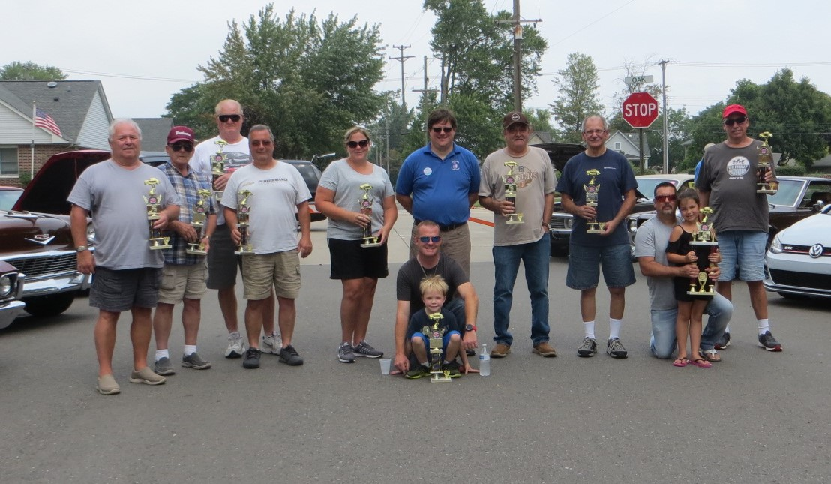

**6th ANNUAL CAR SHOW**

All of our trophy winners, “ICE”, Wyandotte Police, volunteer Ralph Nagy, great tunes, and more! The entire 2018 Trinity Car Show photo album is available on Trinity’s Facebook page. Thanks to Mike Johnson & Family for all your hard work putting this together!

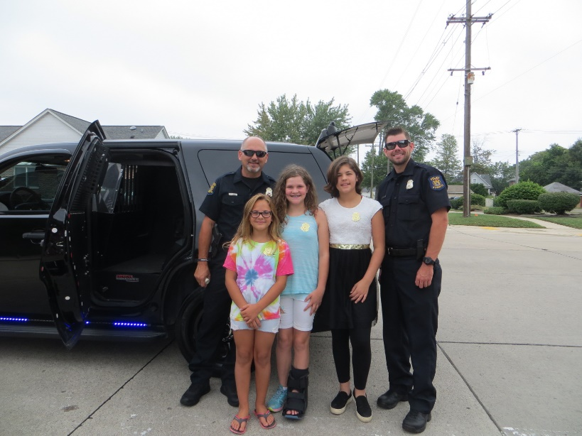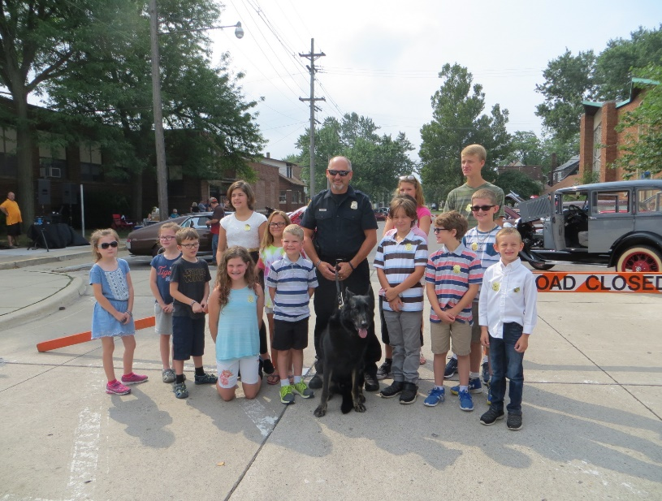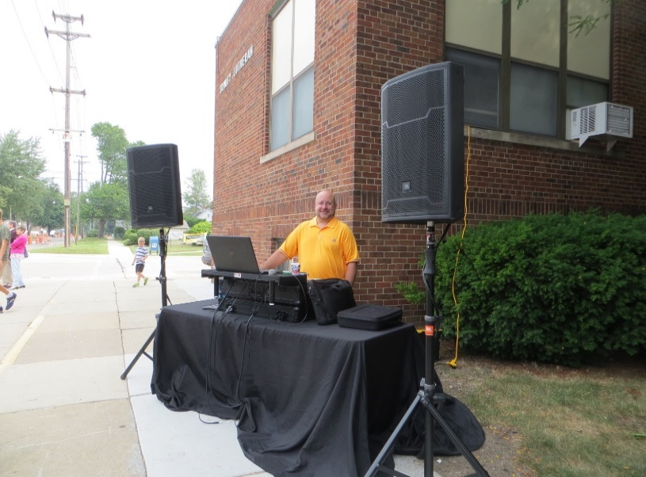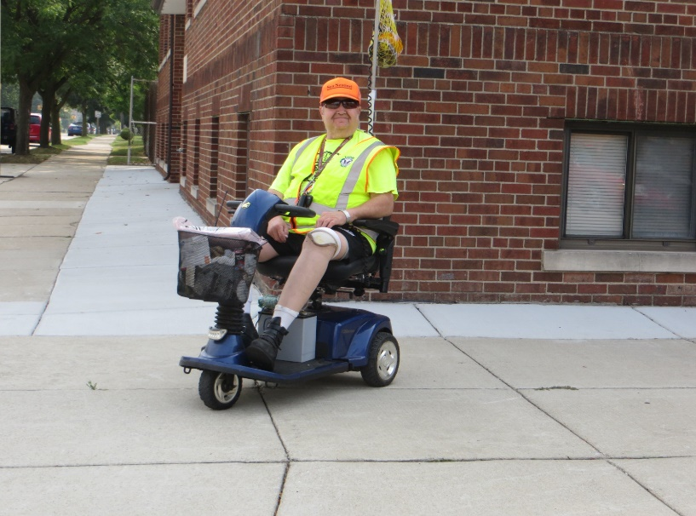

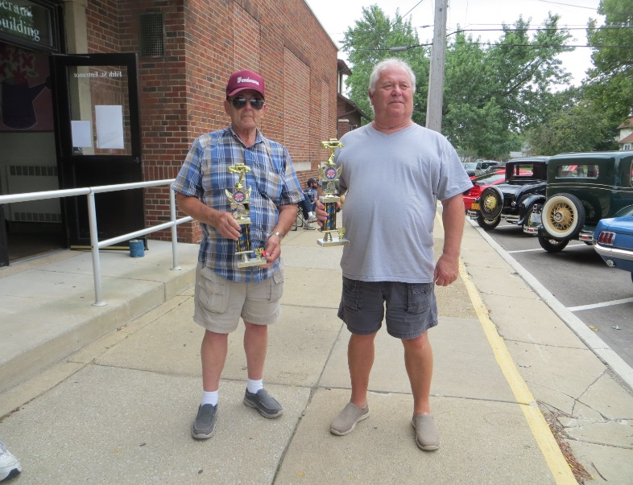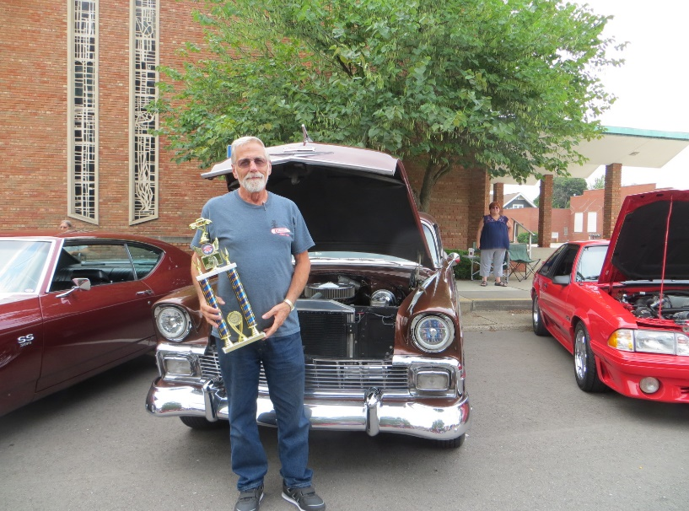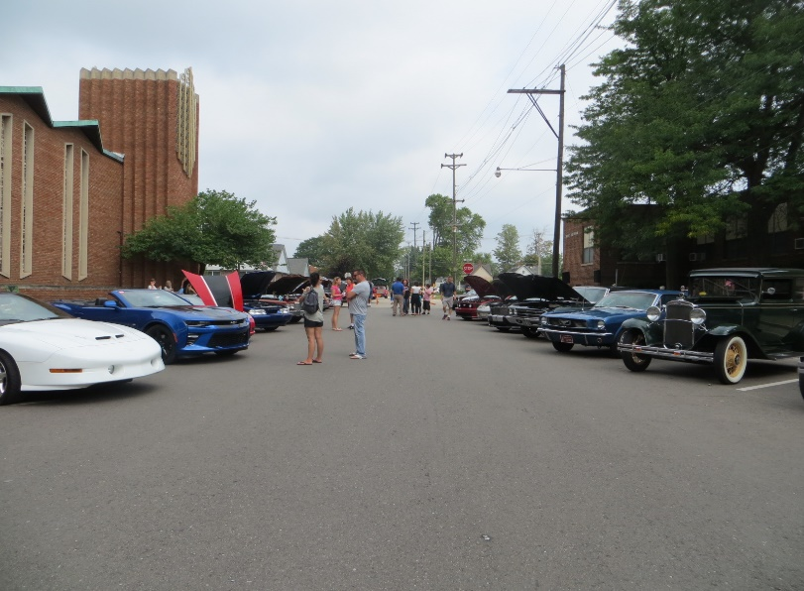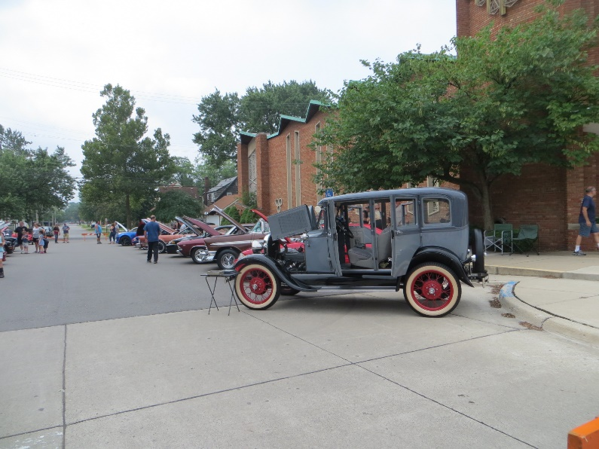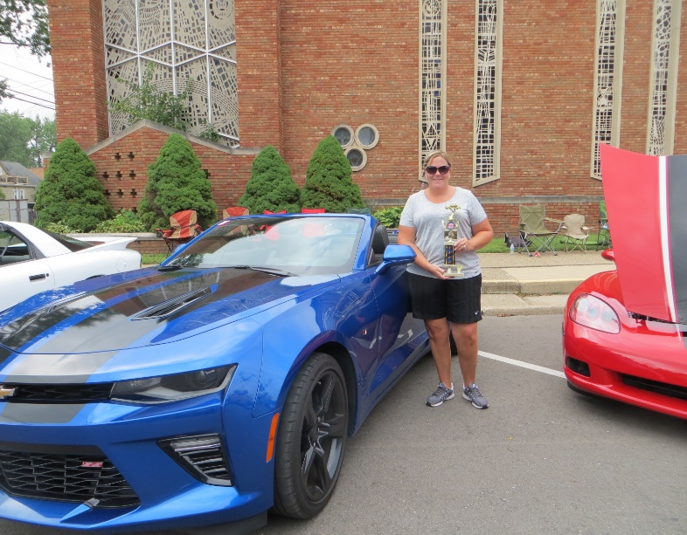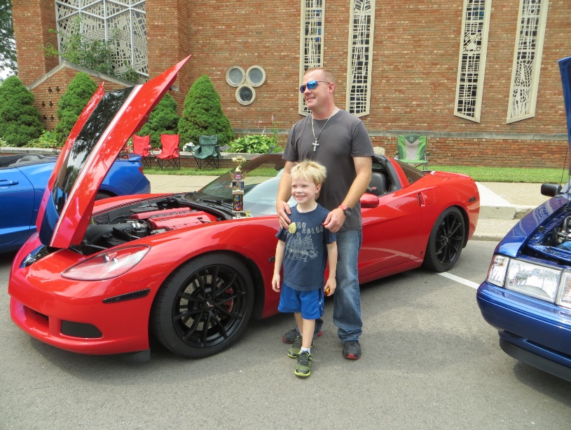



**MAD SCIENCE NIGHTS 2018**

Mad Science Nights was a three-night camp where kids in 4th-6th grades got to learn about magnets, the power of air, and chemical reactions like the elephant paste seen below. We had such a great time and can’t wait to do it again next year! Thank you to all who donated, volunteered and prayed for this program!

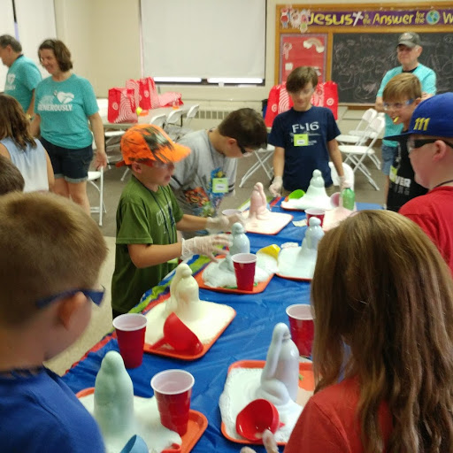 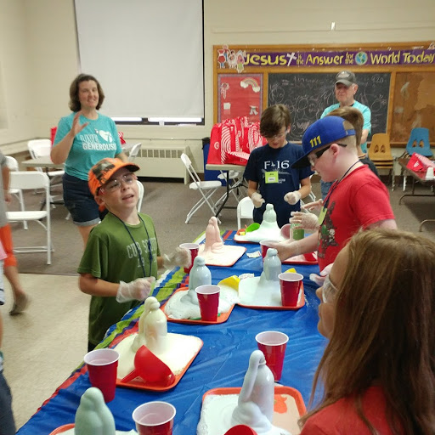

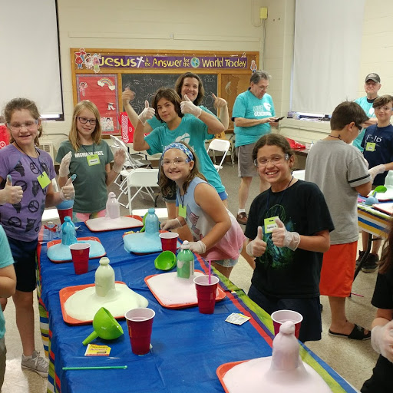

The Endowment Fund has 6 cemetery lots for sale.

**Glen Eden Lutheran Memorial Park:**

Section 228, Graves 3&4, Block 16 – Garden of Hope, $900.00 each. (Current value $1,500.00 each)

Section 1662, Graves 1, 2, 3 & 4, Block 20 – Garden of Holy Trinity, $780.00 each or 4 lots for $2,800 (Current value $1,300 each)

**If an individual would prefer a different lot or location at Glen Eden Lutheran Memorial Park than those listed above, they could purchase the above lot/lots for the price indicated and Glen Eden Lutheran Memorial Park will apply the current lot value of either $1,300 or $1,500  towards the purchase of any other available lot within the Park. For additional information on this purchase and transfer procedure you may contact Floyd Schafer or call a Service Representative at Glen Eden Lutheran Memorial Park at 1-248-477-3915.**



1 Clarence Reichenbach 13 Pat Rayle

Brian Arnoldy 17 JoAnna Pirlot

2 Gail Manthey 21 Joselyn Johnson

David Bryson 22 Jimmy Solomon III

5 Donna LaCroix 24 Steven Bragg

6 Adam Trimble Jimmy Solomon

7 Rachelle Solomon 25 Rick Tollefson

9 Chuck Jones 26 Al Britton

Blake Willis 27 Hailey Willis

10 Doug Duford 28 Christie Wilczynski

12 Pat Gallagher Mike Roehrig

Jillian McCall Jennifer Ayrhart

30 Brenna Roehrig



3 Michael & Jan Sampson

5 Ray & Lori Hodges

10 Joe & Valerie Dzagulones

16 Doug & Pam Duford

18 Paul & Brenda Ivity

20 Greg & Cindy Arnoldy

23 Randal & Jodi Demaggio

24 Tom & Julie Trimble

26 Rick & Sande Meilander

27 Christopher & Emily Summers

“For you created my inmost being; you knit me together in my mother’s womb. I praise you because I am fearfully and wonderfully made.”

Psalm 139:13-14a

Jesus said, “Therefore what God has joined together, let man not separate.”

Matthew 19:6

Fund: Given by: In Memory or Honor of:

Building Improvement Matt & Carissa Schafer Memory of Willie Brink

Building Improvement Judy Jarvis Memory of Willie Brink

Christmas Baskets Ilene Begeman Memory of Donald Begeman Sr.

Ed Bender Rick & Sande Meilander Memory of Willie Brink

Endowment Floyd & Jean Schafer Memory of Willie Brink

Endowment Bill Turski Memory of Willie Brink

Endowment Chuck & Louise Heineman Memory of Willie Brink

Food Pantry John Roehrig Honor of Willie Brink

General Bill & Carolyn Racklyeft Memory of Stan Lozon

General Paul & Brenda Ivity Memory of Willie Brink

General Joyce Kubley Memory of Willie Brink

General Karen Lester Memory of Willie Brink

General Men’s Club Memory of Willie Brink

Missions Bob & Pat Schallhorn Memory of Willie Brink

Name Stamps Don & Adele Glinke

Name Stamps Rosemary Keller

Name Stamps Helen Kwalton

Outreach Jerry & Bobbi Parks Memory of Willie Brink

Outreach The Schallhorn Family Memory of Willie Brink

Parking Lot Pat & Evelyn Sirianni

Parking Lot Russ & Joanne Smith Memory of Willie Brink

Parking Lot Tom & Michelle Smith

Parking Lot Christie Wilczynski Memory of Willie Brink

School Supplies Rick & Mary Tollefson Memory of Willie Brink

School Supplies Carol Sampson

Start New Margaret Brink Memory of Willie Brink

VBS Tim & Julie Liphardt Memory of Willie Brink

Welfare Bill Turski